How to read a candle stick chart
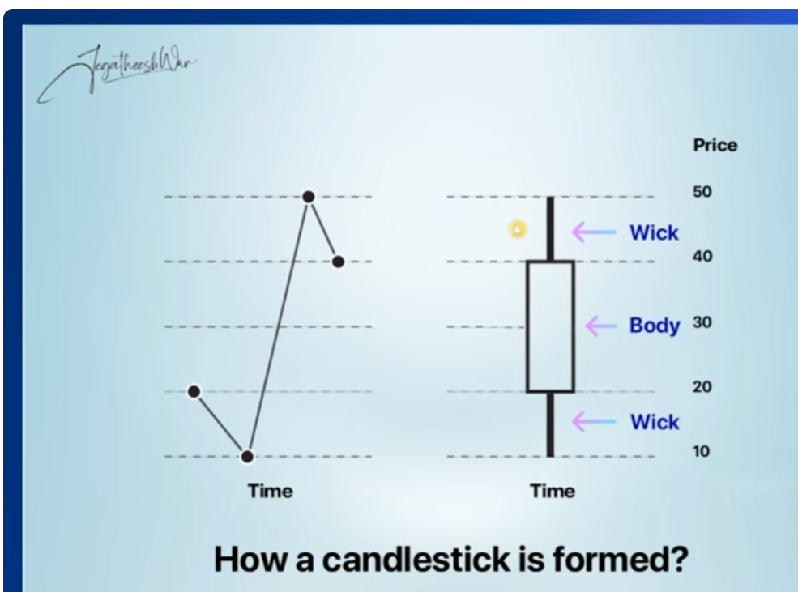
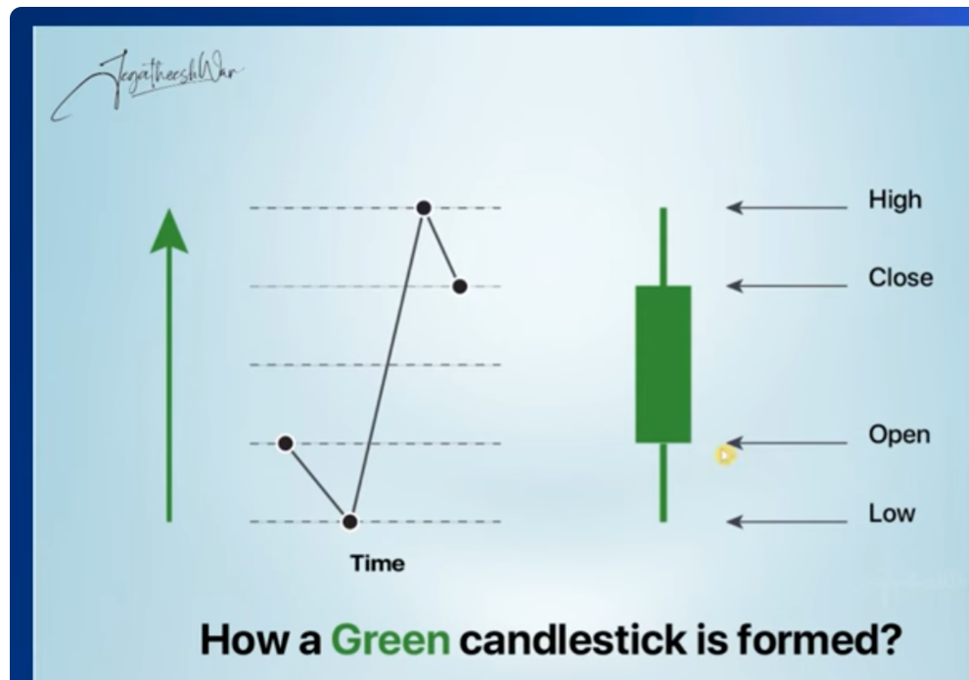
- Wick indicates how long the stock has travelled
- If a stock is less during opening (20) and more while closing(40) – then it forms a green candle.
- If the stock is more during opening (refer below image) and less during closing – then it forms a red bearish candle- eg, if the lines have sno 1,2,3,4,5 – then the trade of a stock is opened at 4 and closed at 2 – so it forms a red candle
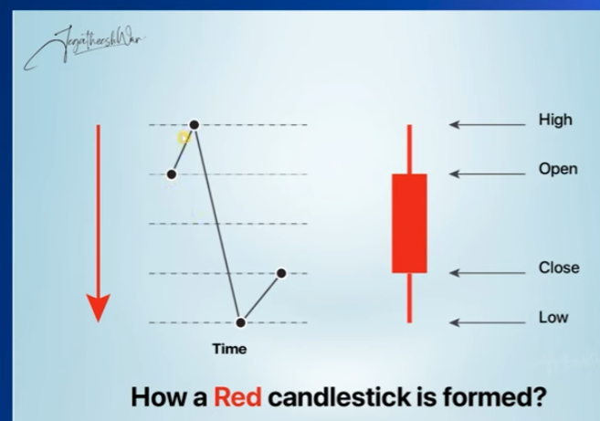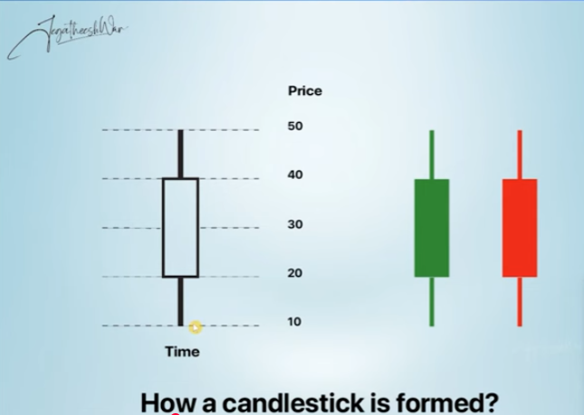

- Trading Strategy - How to Use S/R for Profit

CNC (Delivery) Trading Strategy

Step 1: Identify strong support (3+ touches over 1-3 months)
Step 2: Wait for price to approach support zone
Step 3: Look for bullish reversal candle (Hammer, Engulfing)
Step 4: Buy 10-20% above support if candle confirms
Step 5: Set stop-loss 2-3% below support
Step 6: Target = Next resistance level
Step 7: Hold 1-3 months, don't day trade!
Example:
Support: ₹1,600 | Resistance: ₹1,700
Entry: ₹1,612 (after hammer at ₹1,605)
Stop-loss: ₹1,585 (below support)
Target: ₹1,690
Risk: ₹27 | Reward: ₹78 | Ratio: 1:2.9 ✓

Intraday Trading Strategy
Step 1: Identify yesterday's high/low (becomes today's R/S)
Step 2: Mark opening range (9:15-9:30 AM high/low)
Step 3: If breaks above opening high → Buy for resistance
Step 4: If breaks below opening low → Sell for support
Step 5: Target = Previous day's high/low
Step 6: Strict stop-loss 0.5-1% (intraday risky!)
Step 7: Exit by 3:00 PM, never carry overnight in MIS
Example (HDFC Bank):
Yesterday's High: ₹1,642 (resistance today)
Yesterday's Low: ₹1,618 (support today)
Opening: ₹1,628 | High 9:30: ₹1,632 | Low 9:30: ₹1,625
If breaks ₹1,632 at 10 AM → Buy | Target ₹1,642 | SL ₹1,625

PART 4: HOW TO IDENTIFY SUPPORT & RESISTANCE ON ZERODHA KITE
Step-by-Step Process:

STEP 1: Open HDFC Bank chart in Kite

STEP 2: Set proper timeframe
→ For CNC (long-term): 1D timeframe + 6M or 1Y view
→ For Intraday: 15M or 1H timeframe + 5D view

STEP 3: Look for "horizontal price zones"
→ Where price touched multiple times and bounced/rejected

STEP 4: Use Drawing Tools
→ Click "Tools" icon (top right)
→ Select "Horizontal Line"
→ Draw line at levels where price bounced 2+ times

STEP 5: Mark levels
→ Draw GREEN line where price bounced up (Support)
→ Draw RED line where price fell down (Resistance)

STEP 6: Zoom out to confirm
→ If line touches 3+ candles over 1-3 months = Strong S/R ✓
→ If touches 1-2 times only = Weak S/R ⚠️
Visual Guide - What to Look For:
STRONG SUPPORT (✅ TRADE HERE):
↓ Try to break
███ Failed
↓ Try again
███ Failed
↓ Try third time
███ Failed again!
══════════════════ ← Support at ₹1,600
↑ Bounced 3 times = STRONG!

Action: BUY near ₹1,600-1,610 ✓

WEAK SUPPORT (⚠️ BE CAREFUL):
↓ Touched once
███
────────────────── ← Support at ₹1,600
↑ Only 1 bounce = WEAK

Action: Wait for more confirmation ⏸

CLAUDE EXPLANATION OF CANDLES WHEN TO BUY AND SELL

Step 1 : candle chart 1day -15mins
CANDLE 1 – STARTED AT 9AM

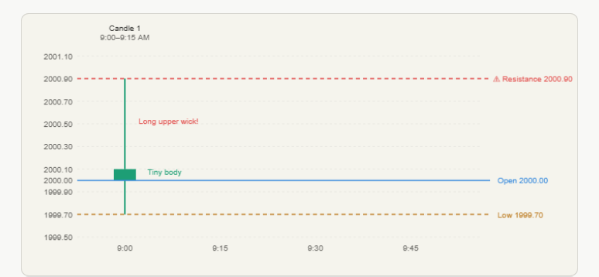
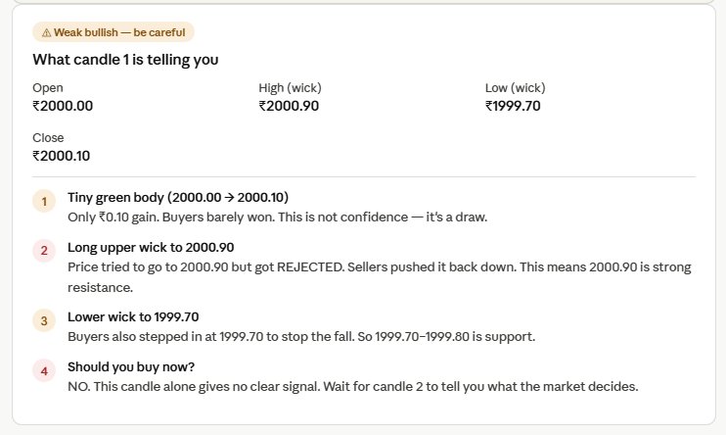

CANDLE 2 – FORMING AT 9.15AM
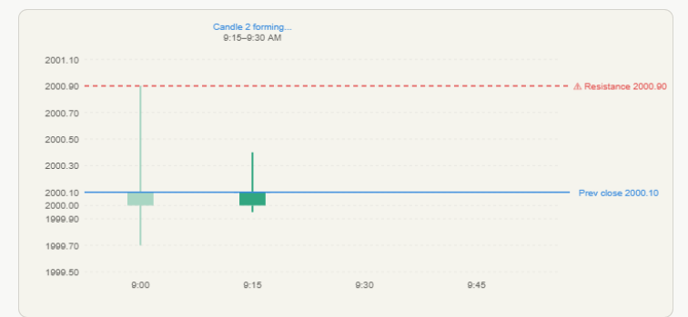
EXPLANATION
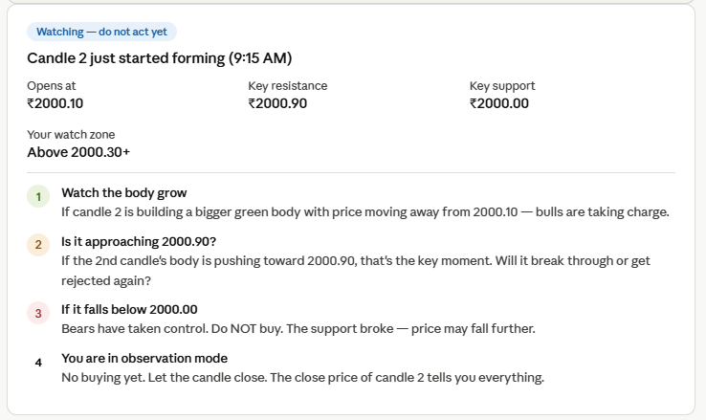

CANDLE 3 -SCENARIO A- BUY SIGNAL
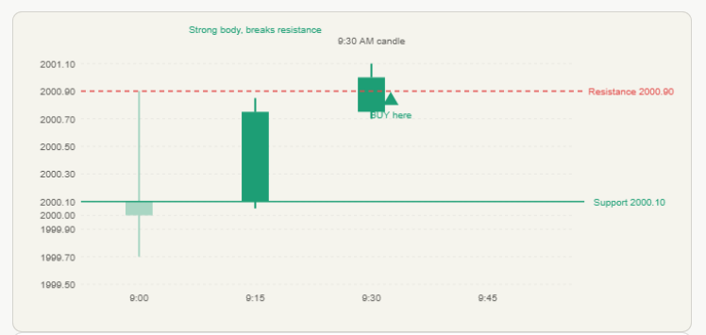
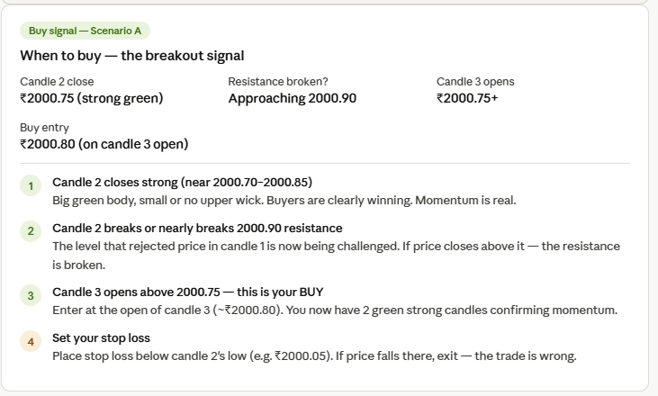

SCENARIO B – AVOID /WAIT
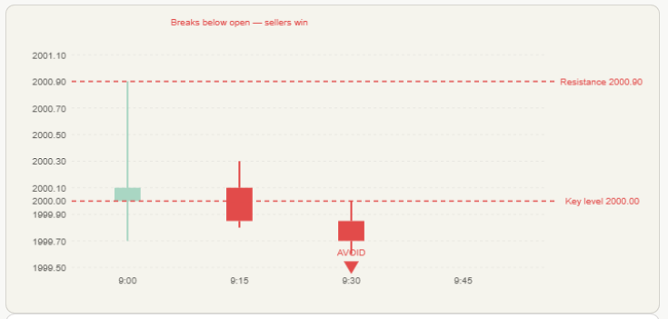
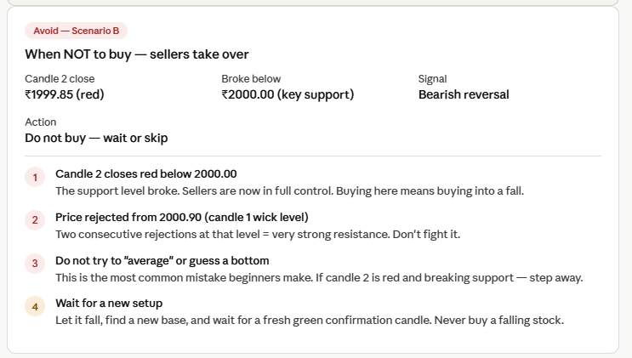

DECISION CHECKLIST
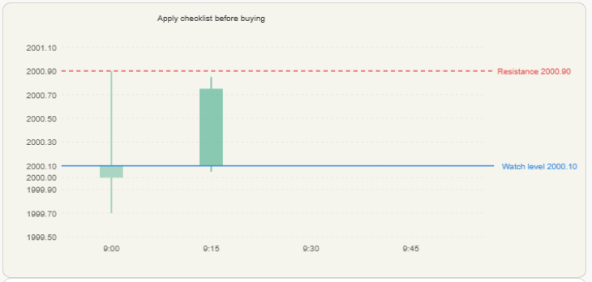
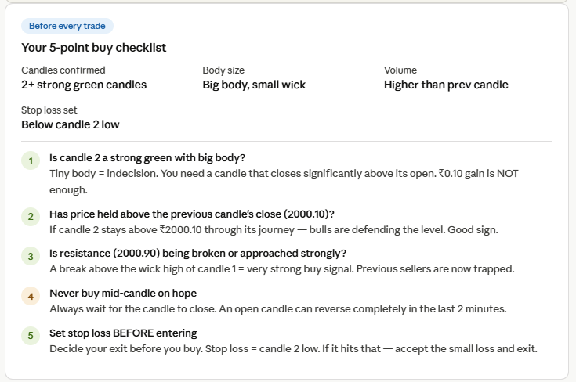

General Rules and Regulations:
- Never make a buy decision on an open candle
- The candle could flip red again before it closes. Wait for the candle to close and THEN decide. The close price is the verdict.
- The candle hasn't decided yet
- Whatever price is showing RIGHT NOW is the "current close" — but it will keep changing. The final close only locks in when the 15 minutes end. This is a candle in progress.

SUPPORT AND RESISTANCE EXPLANATION
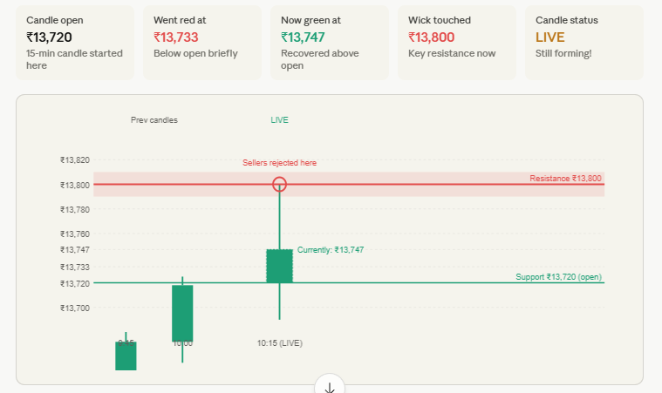
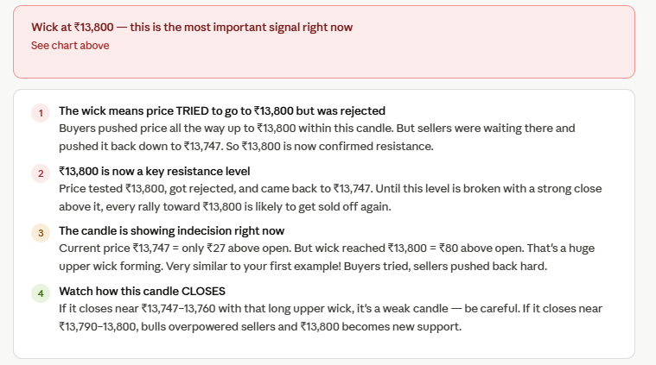

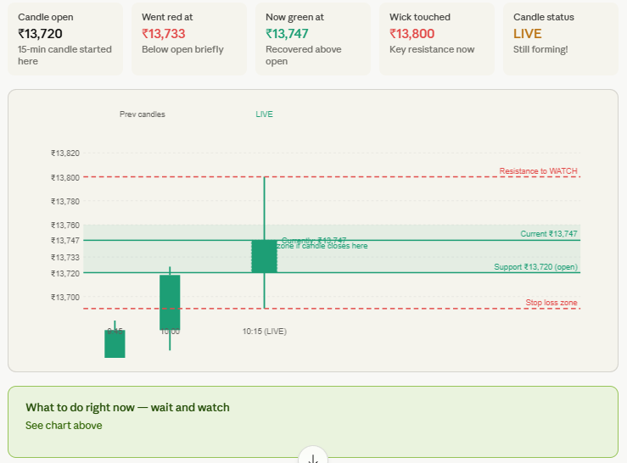
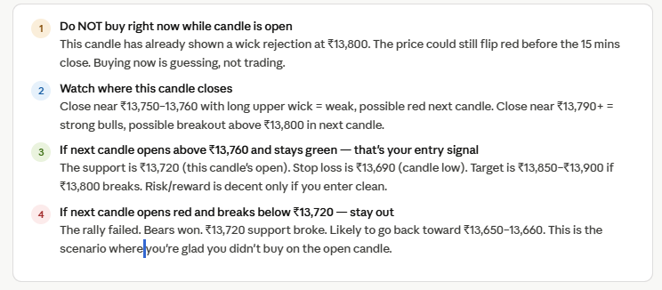
On the 15-min timeframe: One candle = exactly 15 minutes of all trades compressed into one shape. The open locks at second 0, the wick stretches as price moves, the color flips every time price crosses the open, and the close locks at second 899. After that the candle is frozen forever and a brand new candle starts.
On when exactly to buy: Never buy a moving color. Your entry point is the first 1–2 minutes of the NEXT candle after a candle with a strong close. Not mid-candle, not on hope — on confirmation of the new candle opening strong and holding.
On support — your main doubt: Resistance was easy for you because you can see the ceiling visually. Support feels invisible because you're looking for a floor. Here's the simple way to see it — look at the bottom wicks of candles. Wherever 2–3 bottom wicks are touching nearly the same price and bouncing back up, draw a line there. That's your support. It's formed because traders placed buy orders at that price after seeing it bounce once — and those orders pile up, making the floor stronger each time.
On predicting the next candle: You're not predicting — you're reading probability from 4 clues: body size, wick length, where the wick was rejected, and where lows bounced. Those tell you the most likely scenario. The chart shows all 3 possible next candles so you're prepared for each outcome before it happens.

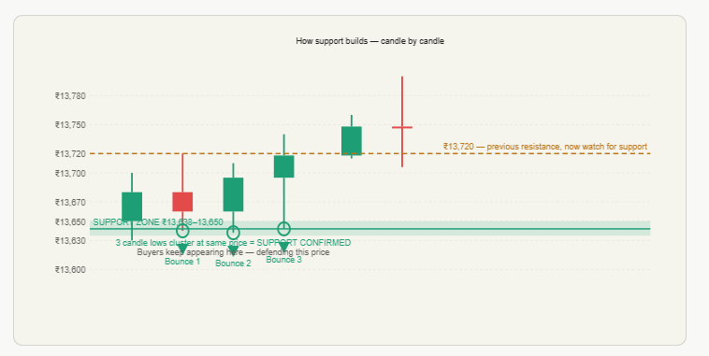

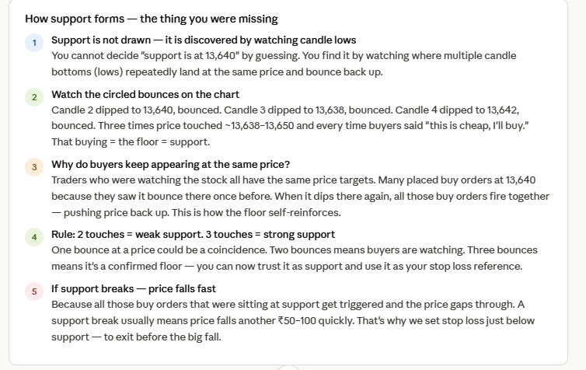
PREDICTING THE NEXT CANDLE
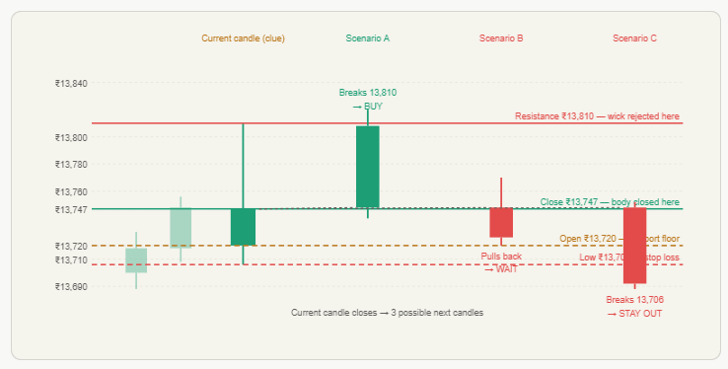
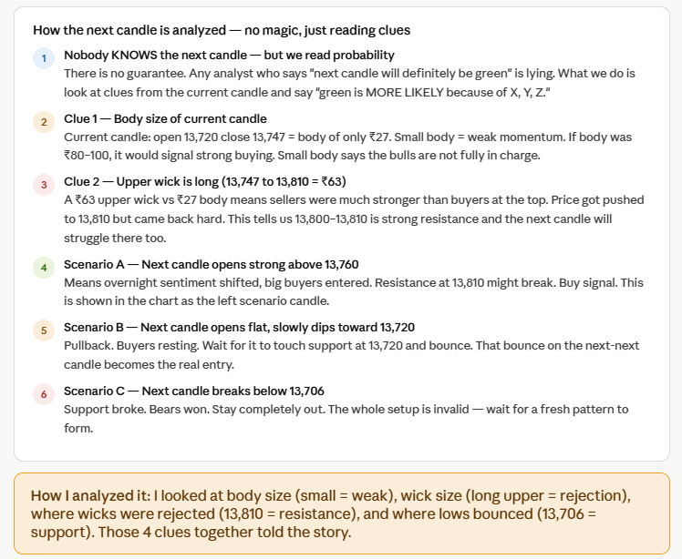

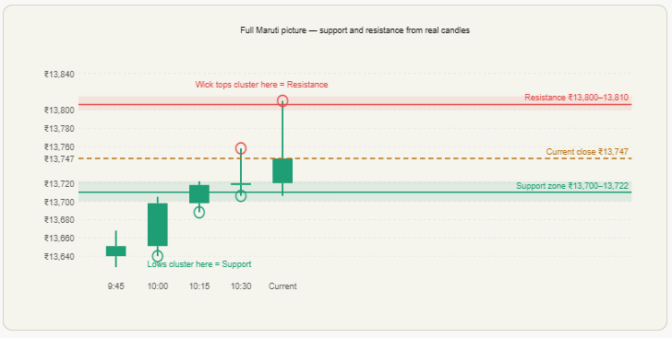
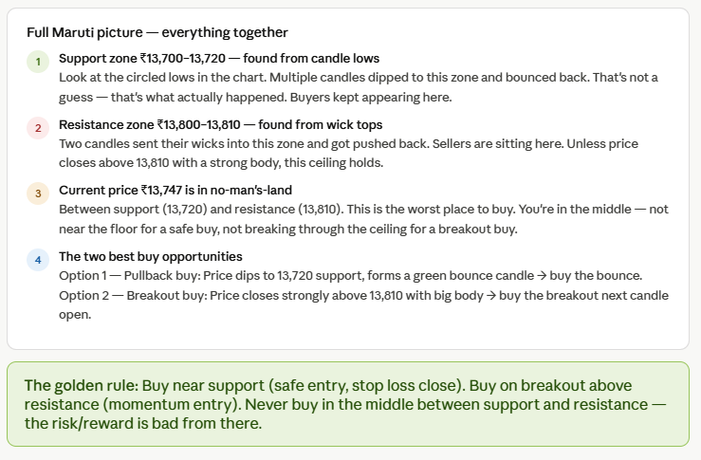

Full analysis
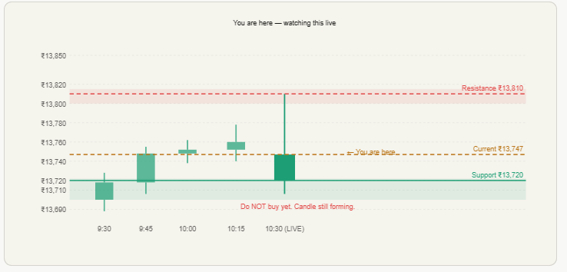

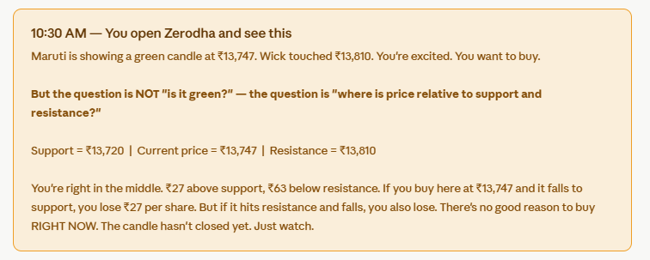
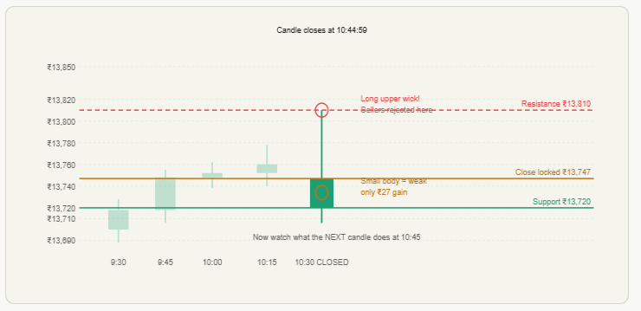
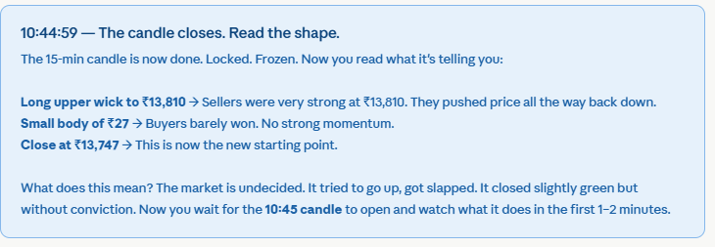
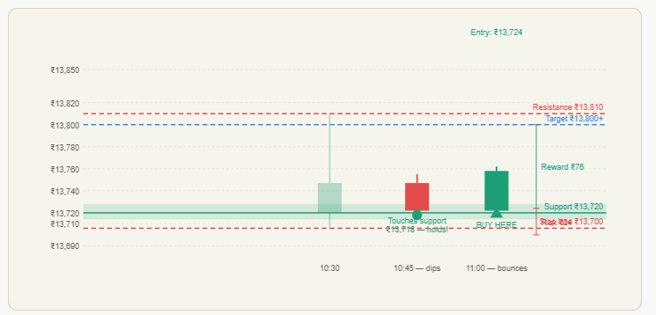
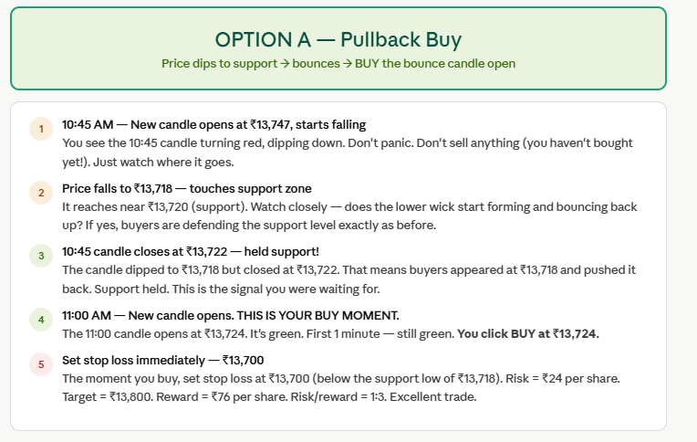
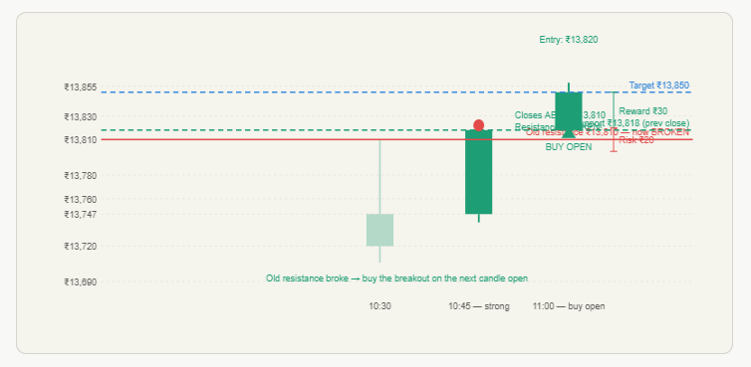
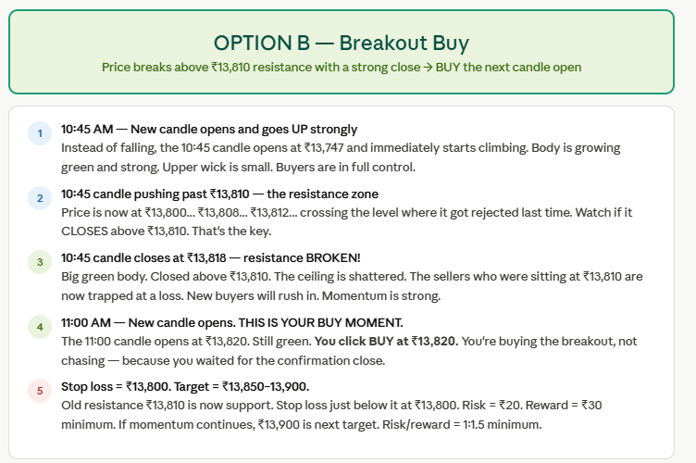

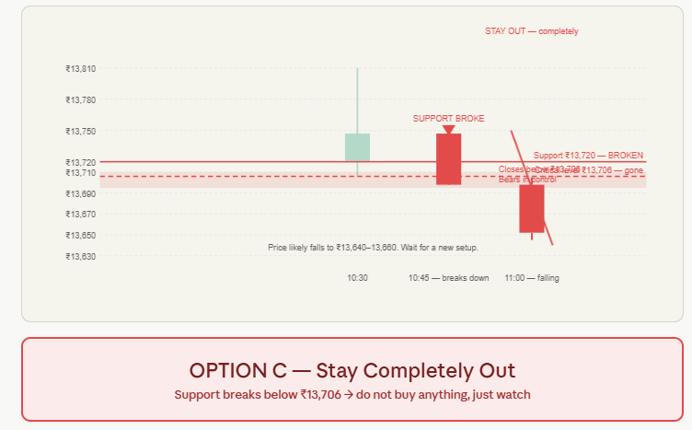
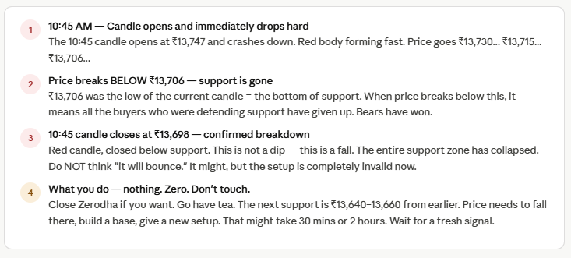

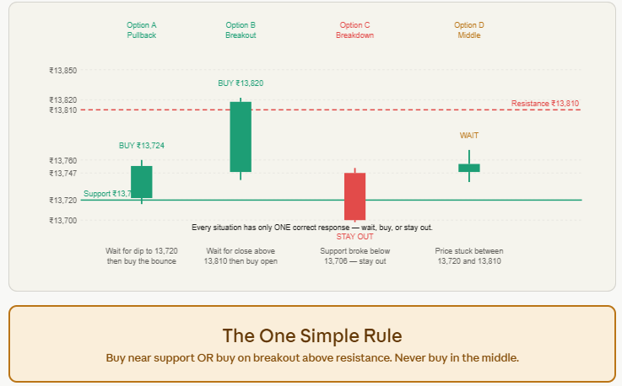
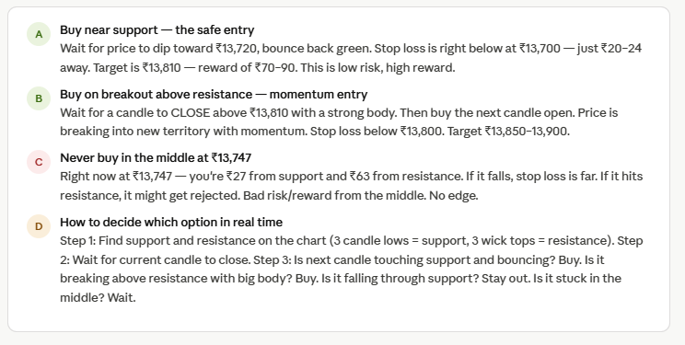
Click through all 6 scenes in order — they tell a complete story from watching to buying.
But here is the single most important thing I want you to understand:
You are not choosing a price. You are choosing a MOMENT.
The price doesn't matter much. ₹13,724 or ₹13,820 — both are fine entries IF the setup is right. What you're really deciding is: has the market given me a clear signal yet? And the answer is always one of three things:
Price touched support and bounced green → BUY the next candle open. Your stop loss is right below that support, so your risk is tiny.
Price closed strongly above resistance → BUY the breakout on the next candle open. The ceiling just broke. Momentum is yours.
Price broke below support → STAY OUT. Nothing to do. No FOMO. No guessing. Just walk away and wait for a new pattern.
The reason you were confused earlier is because you were looking at the price number and asking "is ₹13,747 a good price?" That's the wrong question. The right question is "where is ₹13,747 relative to support and resistance?" And the answer was — stuck in the middle. That's why waiting was the correct action, not buying.

